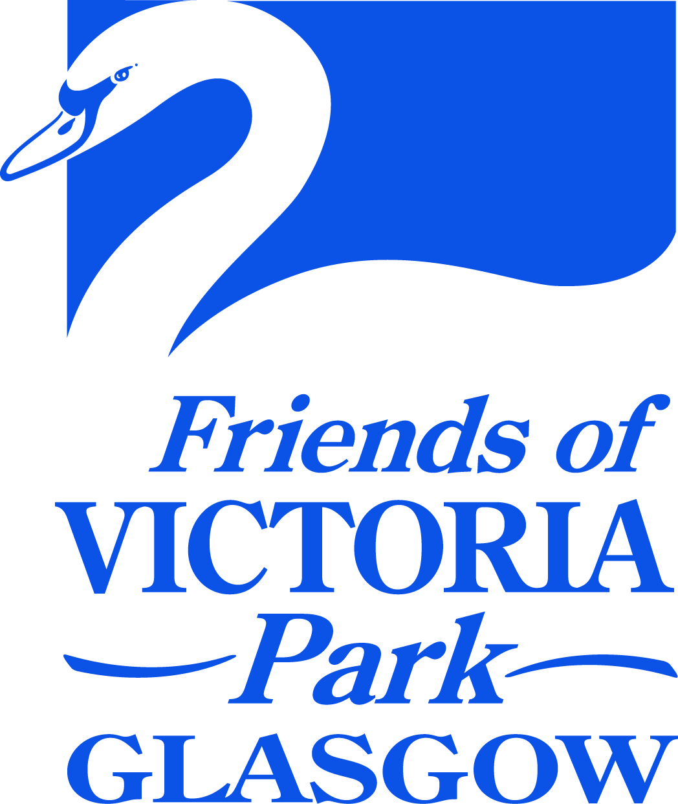

Friends of Victoria Park
DRAFT MINUTE: Virtual AGM Meeting 7:30pm 19 May 2021

Committee Attendance: M. Herrigan (Convenor), G. Herrigan (Treasurer and Acting Secretary), C. Russell, D. Webster, R. McKay. Ben Shepherd

Apologies: E. Brown (Vice-Convenor),

Agenda Items 1. and 2. Welcome, Introduction and Talks

M. Herrigan (Convenor) welcomed everyone and introduced the speakers; Susan Harris on our Park’s Birdlife and Jane Butterworth, Head Flower Farmer of Dear Green Flower Farm.
This was follows by updates from David Webster on the Fossil Grove and Fernery and M. Herrigan on our activities this year and our future plans ahead of Cop 26.

The formal AGM then followed.

Agenda Item 3. 2020 Minutes for Approval

The Minutes of the AGM Meeting of 20 August 2020 were approved by R. McKay and seconded by Susan Harris.

Agenda Item 3. Matters Arising /Previous Actions

Nothing that is not covered in the Agenda.

Agenda Item 4. Convenor’s Report
M. Herrigan presented the Convenor’s Report.
Since our last AGM our Society has continued its activities albeit under the restrictions that we have been sadly placed under this year.
We had a well attended planting event on 29/08/2020 to put another batch in the ground. We have continued with necessarily constrained activities in the Fernery. Happily with the easing of restrictions we were able to have an event that all members could participate in on 01/05/2021 and plan another planting day for 05/06/2021, further details to follow.
I thank all who were able to participate in our Virtual Doors Open day event. A couple of dozen people were able to attend the Zoom webinar and very many participated in the virtual walk. I should like to thank Richard Baynes and Mark Gormley for their help in devising this event.
David Webster also devised a virtual tour of the Fossil Grove, on 21/09/2020, which was very successful.
We posted our Remembrance Sunday Wreath laying on our FaceBook. Sadly we were unable to have a public event and use our new P.A. as planned. This year we hope to live stream our event.
We managed to find a Covid restrictions compliant way to decorate our Christmas tree
At Easter, unable to hold our usual egg rolling, we had a virtual event involving our local primary schools, Scotstoun and St Pauls and Whiteinch Nursery. I hope this is just the beginning of many fruitful collaborations with our local schools. Scotstoun incorporated a design an Easter egg as part of their STEM learning. (Glasgow Caledonian University) The pupils’ appreciation of their local park was an inspiring force.
If there is anyone present who has web and social media skills please let us know as we want to develop and improve what we our Society does with regard to this area.
We continue our positive engagement with other organisations that have an interest in the park via VPCT. I would like to thank our Co-Convenor, Elizabeth Brown, for all her work on the wording of the necessary documents, e.g. the MOUs and the Park Plan and our member Maisie McCrae for her tireless fund raising, which amongst other projects has enabled our much loved pirate ship to be repaired, via BAE’s support.
On another positive note the Council have fulfilled their promise to repair the bridges on the main pond, which like the rest of the park has had so much more use during lockdown. They have also repaired the damaged Oswald Clock face and the smashed down pipe to the Fossil House.
I hope all of you, if you have not already done so join or rejoin. I very pleased that you can now do this online. We have had 19 new and renewed members via this channel since it was recently activated in April.
I will now hand us over to Gail, our Treasurer, who will tell us more in her report about why your subscriptions and donations are so important.
Thanks for your continued support. Let’s keep up the good work!
Agenda Item 5. Financial Report
G. Herrigan presented the Treasurer’s Report.

You may all now have had a chance to look at the Financial Statement for this year. Whilst our balance looks very healthy, the majority of this money is ring fenced.

We have already received 21 Membership Fees, 20 of which were made using our new Membershipmojo payment system on our Website and Facebook pages. This adds a new way of paying to the already established BACs payment, cash and or cheques. For those members renewing there is no need to complete another Membership Form unless there has been a change in your details. The Membershipmojo system runs on a yearly basis and will send a reminder of the renewal date each year. This is perhaps easier than the current system whereby renewal is not automatic.

With this positive start we will hopefully increase our membership this year. We need members to help facilitate all our events throughout the year. As Michael has already stated without members we have no society. Whilst our Facebook follower nos. looks very healthy at 2,600 and increasing this does not equate to actual Membership of the society. For £5 you can join and, receive voting rights, have your say in prioritising the list of events in our Action Plan and have a voice in what happens in your park.
I would encourage everyone, who has not already done so, to renew their membership and encourage family, friends and neighbours to join our society. This will allow us to continue with the good work done so far on the Fernery; our regular events and to develop future activities.

We have been awarded three grants in this financial year. A grant from GCC of £500 for an outdoor PA system to help facilitate our outdoor activities. A Wee Green Grant of £1651 for a bench and willow trees as a memorial to all who have suffered during this pandemic. A grant of £2250 from the Fossil grove Trust for the Fernery Project and I would like to thank them for their continued support.
I would like to take this opportunity to thank you all for your support.
Agenda Item 6. Election of Office Bearers and Committee
Convenor: Michael Herrigan’s re-election was proposed by R. Mckay and seconded by R. Mellish
Vice-Convenor: Elizabeth Brown’s re-election was proposed by G. Herrigan and seconded by M. Herrigan
Secretary: Cathie Russell had indicated, prior to the AGM, her intention to step down from this role. R. Mckay was elected in her place, proposed by M. McCrae and seconded by S. Harris
Treasurer: Gail Herrigan’s re-election was proposed by M. Herrigan and seconded by S. Donaldson
Ordinary Members: Duncan Speirs had indicated, prior to the AGM, his intention to step down from the committee.
David Webster confirmed his intention to remain on the committee
Ben Shepherd confirmed his intention to remain on the committee
M. Herrigan thanked everyone for their continued support. He thanked Cathie for her hard work and support during her time as Secretary and passed on his hope that she would consider remaining on the committee.
One of our new members A. Scarrott indicated a potential interest in joining the committee. M. Herrigan to speak to her separately after the AGM.
Another new member M. Redmond suggested that we should link in with Instagram to share some of the amazing photos that are on our Facebook. M. Herrigan to speak to her separately after the AGM.
Agenda Item 7. AoCB
M. Redmond asked if the plants in the Quarry Know pond would help to regulate the varying condition of the pond from nearly drying out to flooding? D. Webster explained the difficulties with the pond being lower at one end than the other and the fact the pond was re-lined but this lining has cracked. He advised that we can control things with a tap. S. Harris advised that the pond life is not in any danger as they can survive in as little as a couple of inches of water.
A. Scarrott asked if the post re joining could be pinned to the top so as to be easily accessible. R. Mellish advised that it now was.
M. Herrigan thanked the Guest Speakers and all for attending.

